**HOSPITAL MANAGEMENT SYSTEM**

**PROJECT REPORT**

* **ABSTRACT**

The Hospital Management System (HMS) is a comprehensive software solution designed to optimize the management of various healthcare processes within a hospital or healthcare facility. It incorporates modules to efficiently manage entities such as doctors, patients, prescriptions, appointments, wards, inventory, departments, treatments, billing, and tests. Doctors, representing healthcare professionals within the hospital, are organized by ID, name, specialization, contact details, and schedule. Patients, the individuals receiving medical care, are tracked by ID, name, contact information, medical history, and insurance details. Prescriptions detail medications prescribed by doctors, including dosage, frequency, and instructions. Appointments between patients and doctors are scheduled and managed, capturing relevant details such as appointment ID, patient and doctor IDs, date, time, and status. Wards, where patients are accommodated during their stay, are categorized by ID, type, capacity, availability, and assigned staff. Inventory management tracks medical supplies, equipment, and pharmaceuticals, recording item details, quantity, price, stock levels, and supplier information. Departments within the hospital, such as cardiology or pediatrics, are organized by ID, name, description, and department head. Treatments administered to patients are recorded with treatment ID, patient and doctor IDs, date, description, and outcome. Billing manages invoicing and payment processes for patient services and treatments, tracking billing ID, patient ID, invoice details, total amount, payment status, and history. Tests and diagnostics performed on patients are captured with test ID, patient and doctor IDs, test type, date, results, and interpretation. By integrating these entities, the HMS streamlines healthcare operations, enhances patient care, improves efficiency, and ensures effective resource management within the hospital environment.

* **INTRODUCTION**

A Hospital Management System (HMS) is a sophisticated software solution revolutionizing healthcare administration and patient care within hospitals. It seamlessly integrates various modules to streamline processes such as patient registration, appointment scheduling, billing, and inventory management. By digitizing and centralizing data, an HMS facilitates efficient communication and collaboration among healthcare professionals, ultimately enhancing the quality of patient care. It's a vital tool in modernizing hospital operations, ensuring smoother workflows and improved outcomes for patients.

At its core, an HMS is a digital ecosystem meticulously designed to integrate and synchronize the myriad processes inherent in hospital administration. By leveraging cutting-edge technology and intuitive user interfaces, it empowers healthcare providers to transcend traditional boundaries, fostering seamless collaboration and communication across departments and specialties. Gone are the days of cumbersome paper-based record-keeping and disjointed workflows; with an HMS, information flows seamlessly, ensuring that every patient interaction is guided by comprehensive, up-to-date data.

* **FUNCTIONAL REQUIREMENTS**
  + - Here are the software functional requirements for a Hospital Management System (HMS):

These functional requirements form the core functionalities a Hospital Management System, enabling healthcare providers to streamline operations, improve patient care, and enhance overall efficiency.

1. **User Authentication and Authorization**:
   * Users should be able to authenticate securely using unique credentials (username/password, biometrics, etc.).
   * Role-based access control (RBAC) should be implemented to manage user permissions based on their roles (admin, doctor, nurse, receptionist, etc.).
   * Different user roles should have access to specific functionalities and data within the system.
2. **Patient Management**:
   * Provide functionality for patient registration, including capturing demographic information, contact details, and medical history.
   * Allow for the creation, modification, and retrieval of patient records.
   * Implement features for patient admission, discharge, and transfer processes.
3. **Appointment Management**:
   * Enable patients to schedule, reschedule, or cancel appointments with doctors or departments.
   * Provide doctors and staff with the ability to view and manage their appointment schedules.
   * Send automated appointment reminders to patients via email, SMS, or notifications within the system.
4. **Doctor Management**:
   * Maintain doctor profiles with details such as name, specialty, contact information, and availability.
   * Allow doctors to update their availability, view patient appointments, and manage their schedules.
   * Facilitate the assignment of doctors to specific departments or wards.
5. **Billing Management**:
   * Generate bills and invoices for medical services provided to patients.
   * Manage insurance claims, including eligibility verification and coordination of benefits.
   * Track payments, issue invoices, and maintain billing records.
6. **Inventory Management**:
   * Track medical supplies, equipment, and pharmaceuticals within the hospital.
   * Monitor stock levels, reorder supplies when necessary, and update inventory records.
   * Integrate with purchasing and accounting systems for seamless inventory management.
7. **Prescription Management**:
   * Record prescriptions issued by doctors, including medication details, dosage instructions, and refills.
   * Maintain a database of medications with information on generic and brand names, dosages, and interactions.
   * Facilitate electronic transmission of prescriptions to the hospital pharmacy for dispensing.
8. **Ward Management**:
   * Assign patients to available beds based on their medical condition and treatment needs.
   * Allocate nursing staff to wards and patients, ensuring appropriate staffing levels.
   * Track patient progress, vital signs, and treatment plans within each ward.

* **ER DIAGRAM**
* This is a high-level overview of the entities, relationships, attributes, and cardinality in an ER diagram for a Hospital Management System.
* Depending on the specific requirements and complexities of the system, the diagram may include additional entities and relationships.

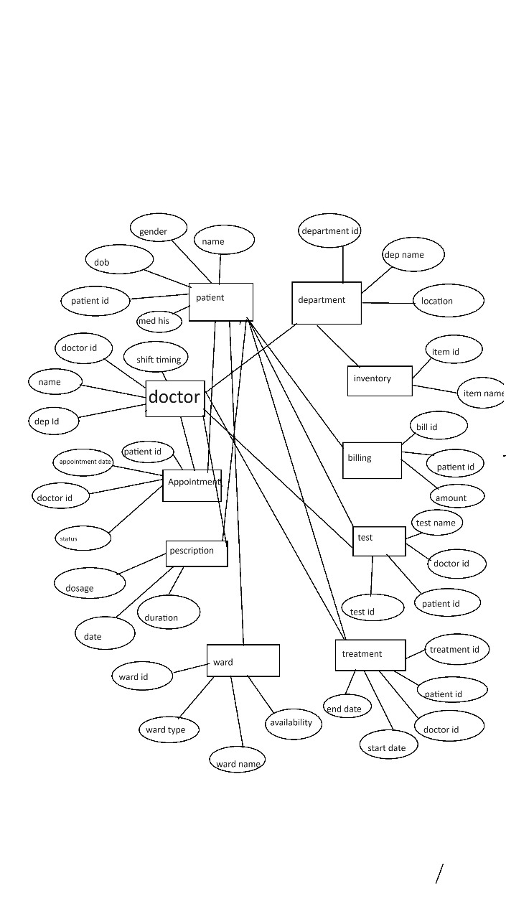

* **UML ATTRIBUTE AND METHODS DIAGRAM**
* UML class diagram representing the entities and their relationships based on the provided information:

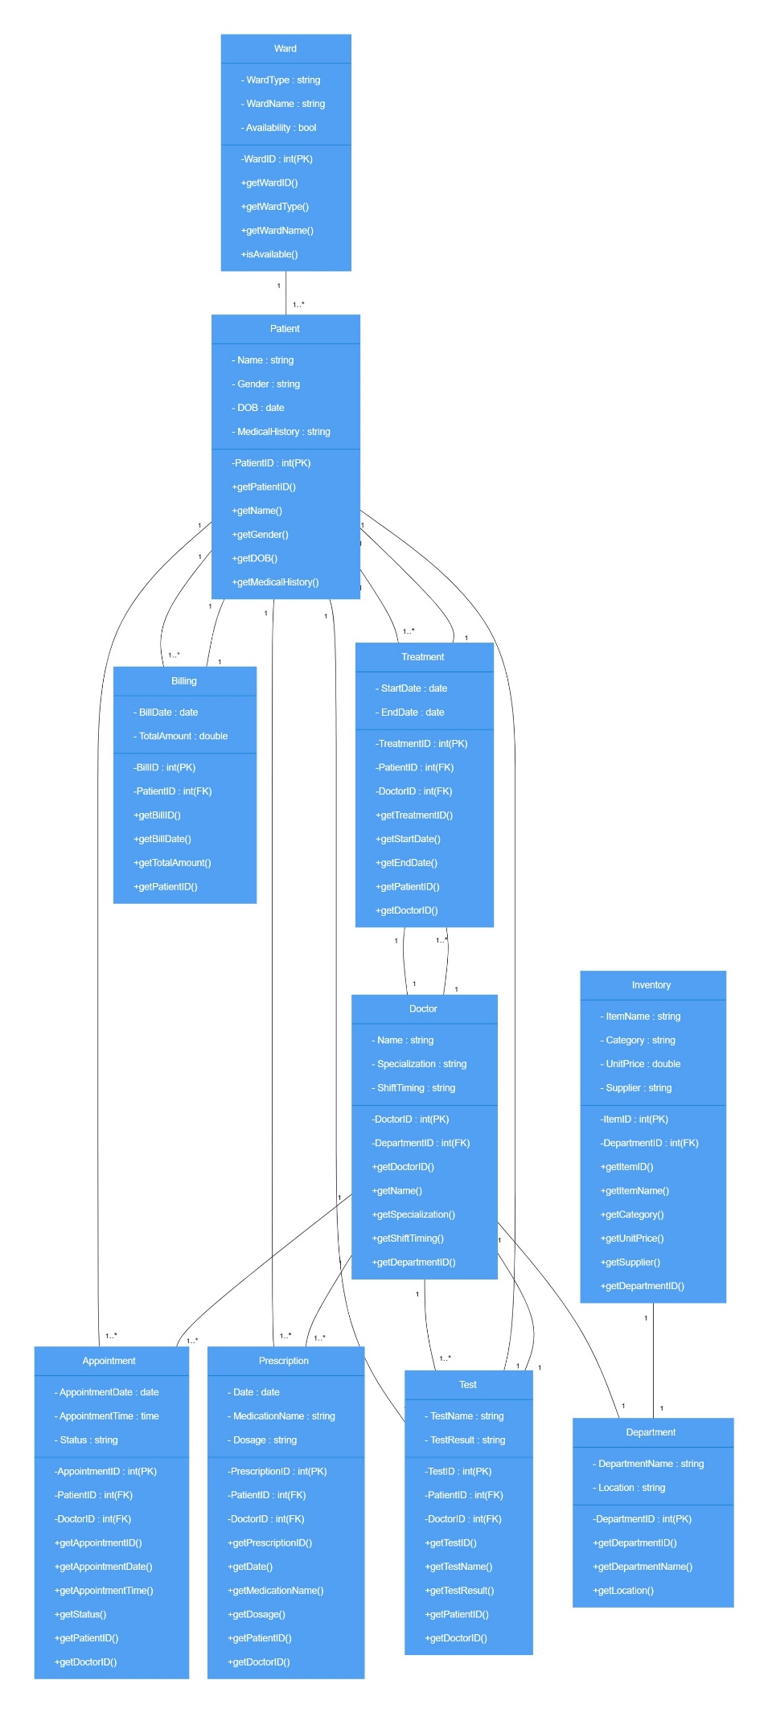

* **CHALLENGES LIST**
* Implementing a Hospital Management System (HMS) can indeed be challenging. Here are some common difficulties faced during HMS project:
* **Requirement Gathering**:

Obtaining comprehensive and accurate requirements can be difficult due to varying needs and priorities across different departments and user groups.

* **Scope Creep**:

Scope creep, where additional features or requirements are added during the project without proper evaluation of their impact on timeline and resources, can lead to delay.

* **Data Migration**:

Migrating data from systems to the new HMS while ensuring data integrity and consistency can be challenging, especially if the data is poorly structured or incomplete.

* **Performance Tuning:**

Optimizing SQL queries and database performance can be challenging, especially when dealing with large datasets or complex queries. Identifying and resolving performance requires understanding of database, query execution , and database configuration.